# **WEEK 1 DESIGN PATTERNS AND PRINCIPLES HANDS ON**

**SUBMITTED BY :-**

NAME – AYUSH SAHOO

SUPERSET ID – 6372243

COURSE – DIGITAL NURTURE 4.0 JAVA FSE

EMAIL – [ayush.sahoo003@gmail.com](mailto:ayush.sahoo003@gmail.com)

COLLEGE – C.V. RAMAN GLOBAL UNIVERSITY

**Exercise 1: Implementing the Singleton Pattern**

**Scenario:**

You need to ensure that a logging utility class in your application has only one instance throughout the application lifecycle to ensure consistent logging.

**Steps:**

1. **Create a New Java Project:**
   * Create a new Java project named **SingletonPatternExample**.
2. **Define a Singleton Class:**
   * Create a class named Logger that has a private static instance of itself.
   * Ensure the constructor of Logger is private.
   * Provide a public static method to get the instance of the Logger class.
3. **Implement the Singleton Pattern:**
   * Write code to ensure that the Logger class follows the Singleton design pattern.
4. **Test the Singleton Implementation:**
   * Create a test class to verify that only one instance of Logger is created and used across the application.

**SOUTION**

**STEP 1:**

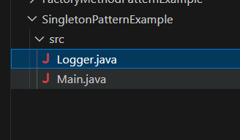

**STEP 2 AND STEP 3 :**

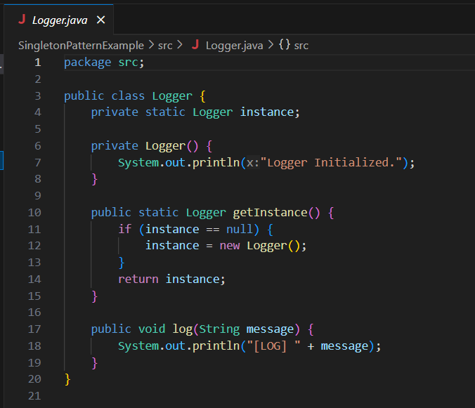

**STEP 4:**

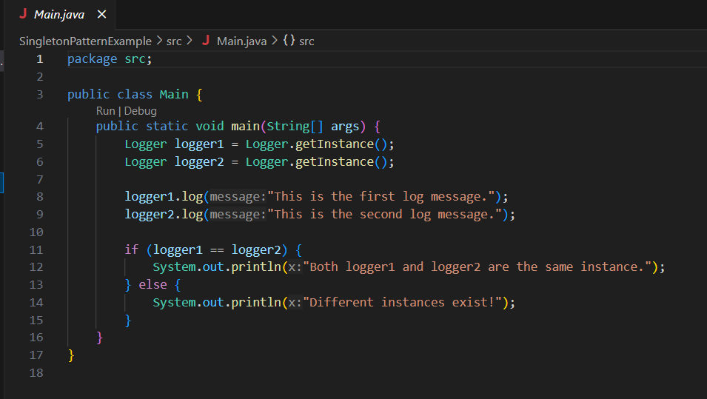

**OUTPUT:**

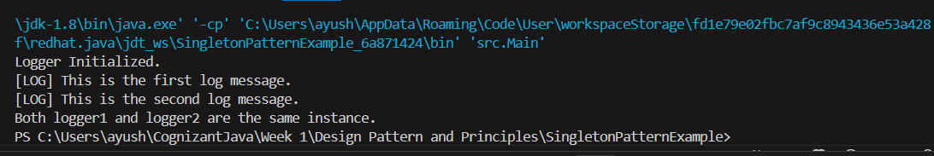

**Exercise 2: Implementing the Factory Method Pattern**

**Scenario:**

You are developing a document management system that needs to create different types of documents (e.g., Word, PDF, Excel). Use the Factory Method Pattern to achieve this.

**Steps:**

1. **Create a New Java Project:**
   * Create a new Java project named **FactoryMethodPatternExample**.
2. **Define Document Classes:**
   * Create interfaces or abstract classes for different document types such as **WordDocument**, **PdfDocument**, and **ExcelDocument**.
3. **Create Concrete Document Classes:**
   * Implement concrete classes for each document type that implements or extends the above interfaces or abstract classes.
4. **Implement the Factory Method:**
   * Create an abstract class **DocumentFactory** with a method **createDocument()**.
   * Create concrete factory classes for each document type that extends DocumentFactory and implements the **createDocument()** method.
5. **Test the Factory Method Implementation:**
   * Create a test class to demonstrate the creation of different document types using the factory method.

**SOLUTION:**

**STEP 1:**

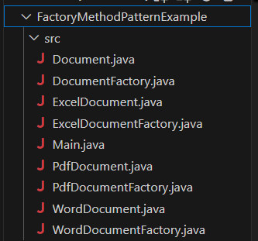

**STEP 2:**

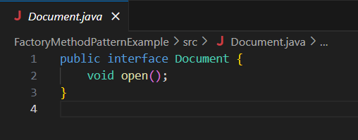

**STEP 3:**

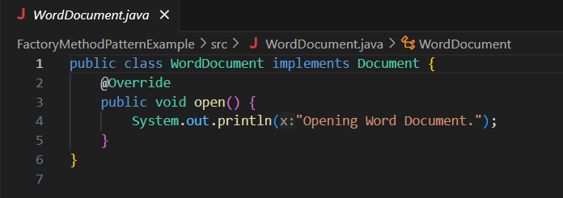

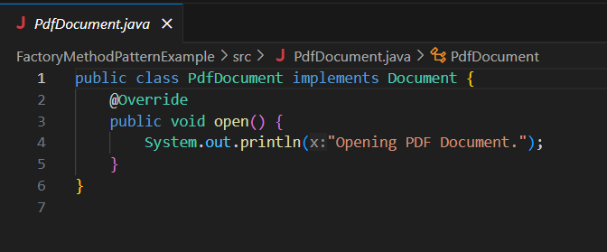

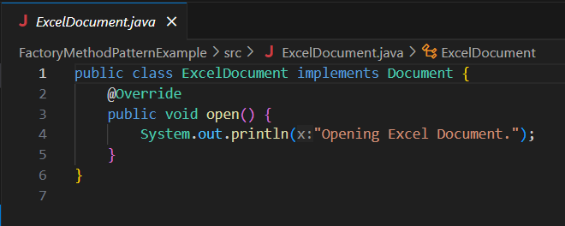

**STEP 4:**

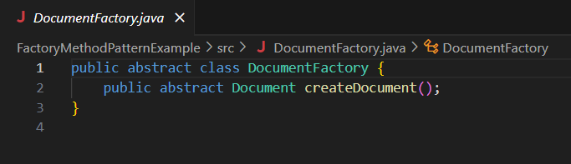

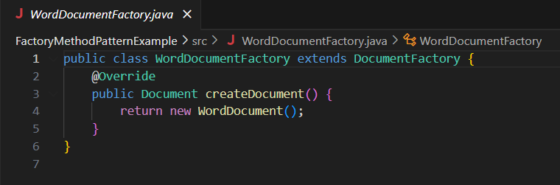

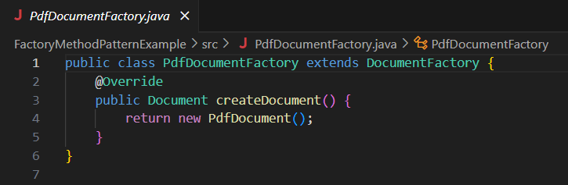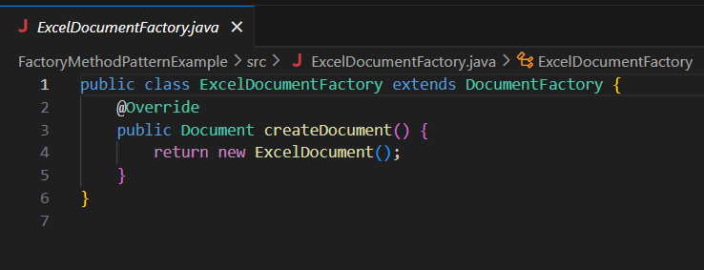

**STEP 5:**

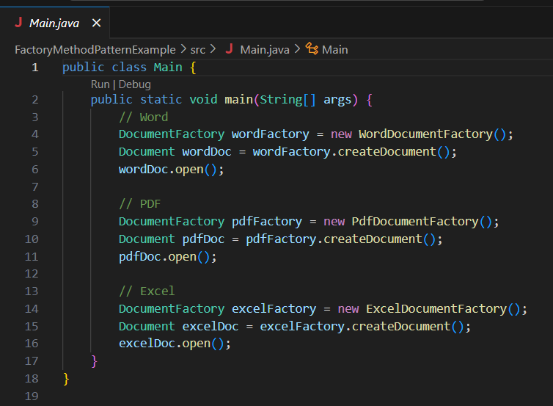

**OUTPUT:**

